Dataset Issue Findings

ArianFinal:
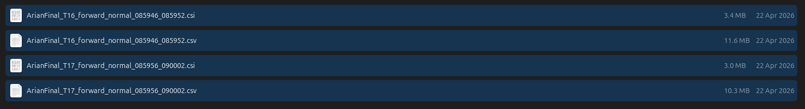
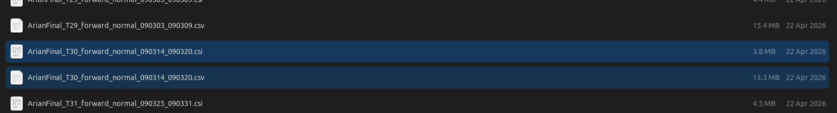
Issue : Low file size

ForhadFinal:
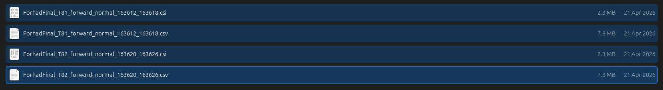
Issue : Low file size

